A MESSAGE FROM STAPLEFORD ABBOTTS PARISH COUNCIL

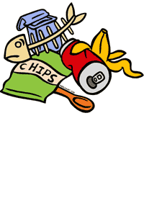
ARE YOU FED UP WITH ALL THE LITTER AROUND OUR VILLAGE?
SO ARE WE!
THAT’S WHY WE’RE PLANNING A BIG PICK-UP DAY, AND LOOKING FOR VOLUNTEERS TO SPARE AN HOUR OR TWO ON “TRASH SQUAD”. WE WILL PROVIDE ALL THE NECESSARY EQUIPMENT FOR THE VENTURE.
STAPLEFORD ABBOTTS IS A BEAUTIFUL VILLAGE AND WE CAN ALL MAKE SURE IT STAYS THAT WAY!
WANT TO HELP? CONTACT THE CLERK: staplefordabbottsparishcouncil@gmail.com

BAG IT – BIN IT – BEAT IT!

